-------------------------------------MODULE 1-------------------------------------

**1.NORMALIZATION**

1 **ST NORMAL FORM (1NF):**

• Each column must contain atomic values and there is no repeating columns.

• One or more columns is primary key, used to uniquely identifying records of the table.

**2 nd NORMAL FORM (2NF):**

• The table is in 1NF.

• All the non-key elements are dependent on primary key ( no partial dependencies are allowed).

**3 RD NORMAL FORM (3NF):**

• The table should be in 2NF.

• There is no transitive dependency for non-prime attributes.

**ENTITY RELATIONSHIP DIAGRAM**

-------------------------------- NORMALIZATION-----------------------------------

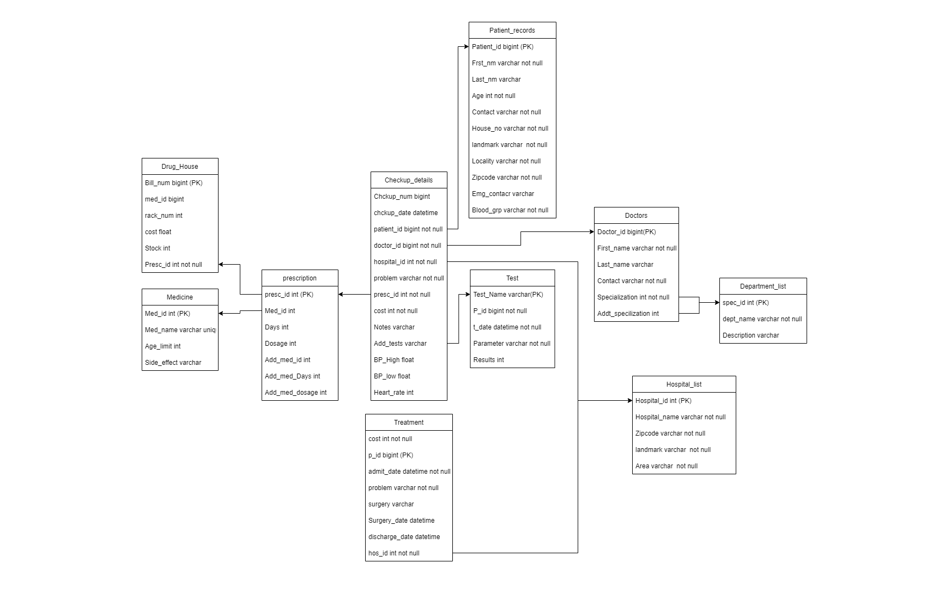

---------------------------------DOCTORS DETAILS------------------------------------

**create** **table** ANITHA_FA_doctors(

doctor_id **bigint** **primary** **key**,

First_name **varchar**(50) **not** **null**,

Last_name **varchar**(50),

dept_name **varchar**(50) **not** **null**,

contact **varchar**(10) **unique** **check**(contact **NOT** **LIKE** '%[^0-9]%')

);

**insert** **into** ANITHA_FA_doctors **values**

(1001,'Narayan',**Null**,'Neurology','9567845321'),

(1002,'Rajeev','Shaneoy','Nephrology','9567855566'),

(1003,'Vedha','Patkar','General','9145338742'),

(1004,'Keshav','B','ENT','6754822211'),

(1006,'Naina','Sahani','Ayurvedic','8767766221'),

(1005,'Arjun','Pandit','General','9119119119'),

(1007,'Narayan','Malvi','General','7654321098'),

(1010,'Veena','Kamath','ENT','9567845322'),

(1008,'Alvin','Dsouza','Ayurvedic','9546565565'),

(1000,'Chaitra','Kulal','Cardiology','9567846632'),

(1009,'Chinmay','Naik','General','8867754321'),

(1012,'Krishna','Shastri','Dental','6466557890');

**select** * **from** ANITHA_FA_doctors ;

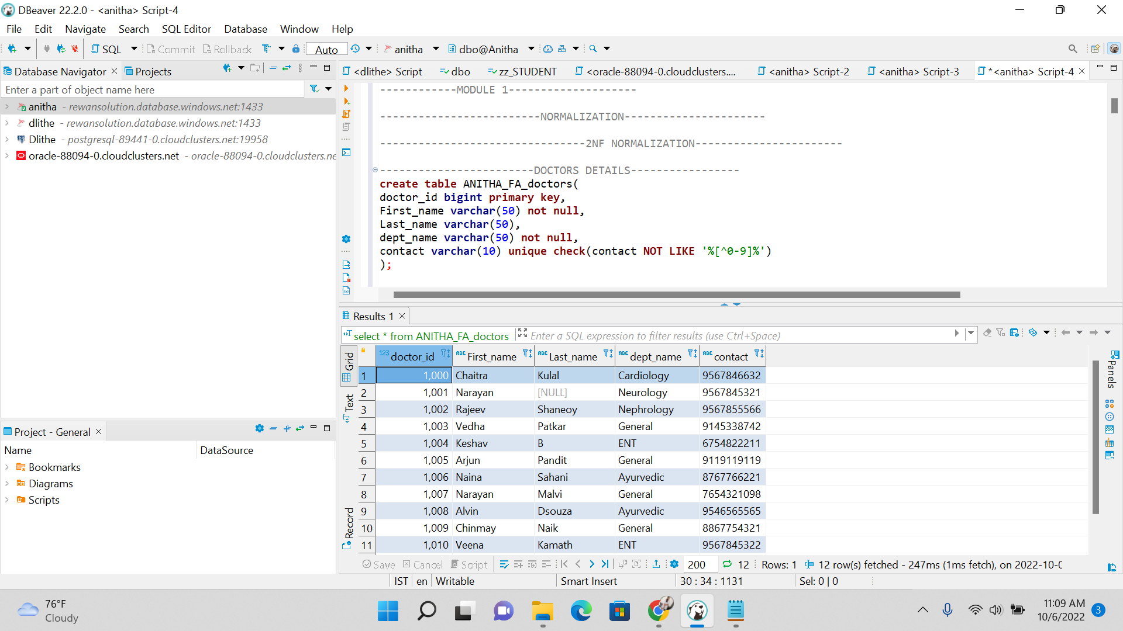

-----------------------------PATIENT DETAILS--------------------------

**create** **table** ANITHA_FA_patient_records(

p_id **bigint** **primary** **key**,

First_name **varchar**(50) **not** **null**,

Last_name **varchar**(50),

gender **varchar**(10) **not** **null**,

age **int**,

address **varchar**(50) **not** **null**,

contact **varchar**(10) **unique** **check**(contact **NOT** **LIKE** '%[^0-9]%')

);

**insert** **into** ANITHA_FA_patient_records **values**

(10001,'Shabeena','Banu','F',39,'Bengaluru','9999998833'),

(10002,'Krishna',**Null**,'M',58,'Bengaluru','6754322109'),

(10003,'Vikas','Jain','M',25,'Tumkur','8899998833'),

(10004,'Ajesh','Dsilva','M',39,'Bengaluru','699698632'),

(10005,'Daisy','Shah','F',32,'Hosur','9229998811'),

(10006,'Mohmmad','Bilal','M',48,'Tumkur','8756332100'),

(10007,'Sharada','Patil','F',12,'Bengaluru','9944563231'),

(10008,'Kirthi','Jain','F',79,'Bengaluru','8766789944'),

(10009,'Laxmi','Bai','T',31,'Hosur','6464655321'),

(10010,'Bhagya','Gowda','F',20,'Hosur','9199213244'),

(10011,'Manish','Paul','M',39,'Tumkur','8484883209'),

(10012,'Raj','Kundra','M',66,'Guntur','9010876120'),

(10013,'Yash','Jogi','M',48,'Udupi','6909896654'),

(10014,'Aruna',**Null**,'F',54,'Bengaluru','7878902345'),

(10015,'Raksitha','Nayak','F',21,'Udupi','8483412141'),

(10016,'Jayantha','Nayak','M',22,'Udupi','9483412141'),

(10017,'Shabeer','Ahmed','F',82,'Hosur','8876546123'),

(10018,'Shabeena',**Null**,'F',67,'Tumkur','9483413132'),

(10019,'Jayantha','Naik','M',40,'Mangaluru','9994448833'),

(10020,'Neeraja','Patil','F',90,'Mangaluru','9995658833'),

(10021,'Vinod','Aiyer','M',76,'Tumkur','8879998833'),

(10022,'Vishist',**Null**,'M',51,'Kolar','9234998833'),

(10023,'Neha','Singh','F',22,'Hosur','9991098833'),

(10024,'Nagashree','Pai','F',29,'Tumkur','9999998125'),

(10025,'Nirmala','S','F',10,'Kolar','9999998558');

**select** * **FROM** ANITHA_FA_patient_records ;

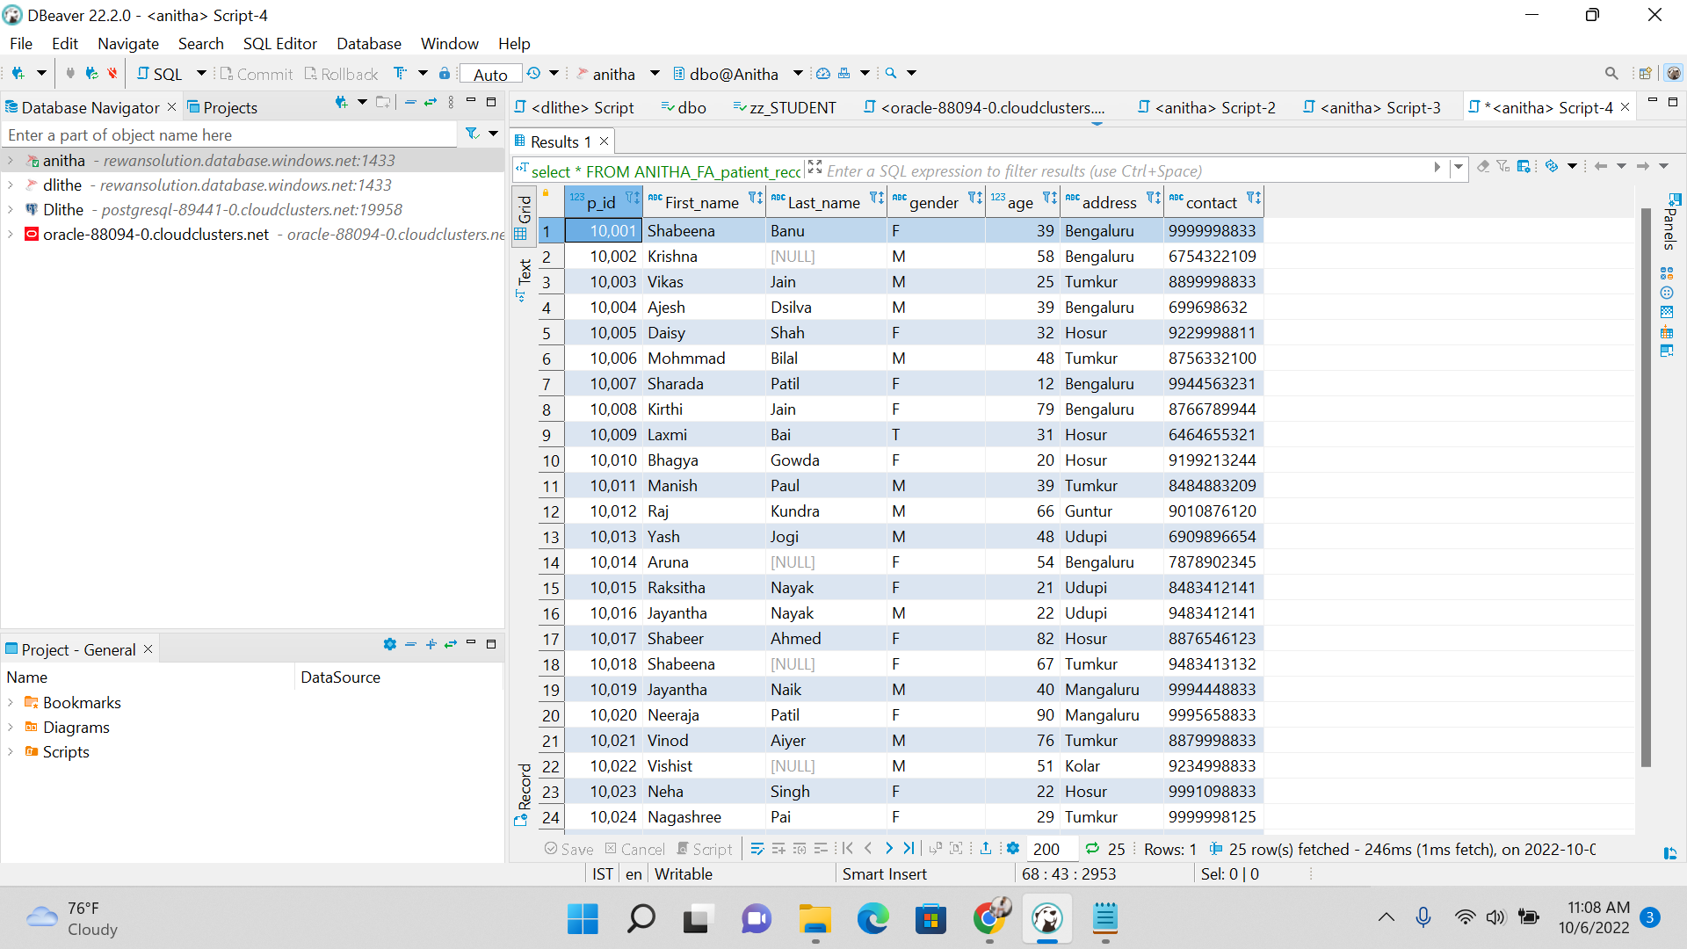

------------------------------DRUG DETAILS-------------------------

**create** **table** ANITHA_FA_drug_details(

drug_id **int** **primary** **key**,

drug_name **varchar**(50) **not** **null**,

Age_limit **int** **not** **null**,

Available_form **varchar**(50)

);

**insert** **into** ANITHA_FA_drug_details **values**(101,'paracetamol',10,'Tablet'), -- cold

(102,'losartan',6,'Tablet'), -- Heart problems

(103,'Quinapril',18,'Tablet'), ---High BP

(104,'Benadryl',2,'Sirup'), --Cough

(105,'hydrogen peroxide',18,'Liquid'), -- cleansing

(106,'hydroxychloroquine',6,'Tablet'), -- Malaria

(107,'aspirin',16,'Tablet'), -- headache

(108,'Hydrogel',0,'Gel'), -- Wonds

(109,'Atonide',1,'Gel'), -- rashes

(110,'Hyoscine hydrobromide',4,'Tablet'), --Vomitting

(111,'Midodrine',5,'Tablet'), --Dizziness

(112,'Bismuth subsalicylate',12,'Tablet'), --loose motion

(113,'NSAID',6,'Tablet'), ---Pain killers

(114,'Albuterol sulfate',4,'Aerosol'), ---Astama

(115,'acetaminophen',6,'Aerosol'), -- fever

(116,'Ferrous Sulfate',12,'Tablet'), ---Blood count increase

(117,'levothyroxine',6,'Tablet'), --Thyroid

(118,'Insulin',10,'Injection'), -- sugar

(119,'Fludrocortisone',9,'Tablet'); -- low BP

**select** * **from** ANITHA_FA_drug_details;

**create** **table** ANITHA_FA_hospital_list(

hospital_id **int** **primary** **key**,

hospital_name **varchar**(50) **unique** **not** **null**,

city **varchar**(50) **not** **null**

);

**insert** **into** ANITHA_FA_hospital_list **values**(101,'Manipal Hospital','Bengaluru'),

(102,'Cura Hospitals','Bengaluru'),(103,'Mallige Hospital','Bengaluru'),(104,'Shree Chowdeshwari Hospital','Kolar'),

(105,'Hope Hospital','Kolar'),(106,'Kasturba Hospital','Tumkur'),(107,'Akshaya Hospital','Tumkur'),

(108,'Vijay Hospital','Tumkur'),(109,'Kauvery Hospital','Hosur'),(110,'Hyma Hospitals','Guntur');

**SELECT** * **FROM** ANITHA_FA_hospital_list;

----------------------------------CHECKUP DETAILS---------------------

**create** **table** ANITHA_FA_checkup_details(

chkup_num **int**,

chkup_date **date** **check** (chkup_date <=**CAST**(**GETDATE**() **AS** **Date**)),

patient_id **bigint** **not** **null**,

doctor_id **bigint** **not** **null**,

hospital_id **int** **not** **null**,

problem **varchar**(50) **not** **null**,

chkup_suggested **varchar**(50),

BP_high **int**,

BP_low **int**,

sugar_level **float**,

p_drug_id **int** ,

**primary** **key**(chkup_num,chkup_date)

);

**insert** **into** ANITHA_FA_checkup_details **values**(1,'2022-10-04',10010,1001,102,'Anckle twist','X-RAY',100,60,236.5,113),

(2,'2022-10-04',10022,1001,110,'Fever',**Null**,110,80,110,115),

(3,'2022-10-04',10001,1003,102,'Chest pain','CT-Scan',70,100,78,102),

(4,'2022-10-04',10003,1002,102,'Smoking','Blood test',140,110,159,**Null**),

(5,'2022-10-04',10002,1005,102,'Regular Chekup','X-RAY',100,60,236.5,113),

(6,'2022-10-04',10021,1003,102,'Bike Accident','X-RAY',120,90,110,113),

(7,'2022-10-04',10019,1001,102,'stomach Pain',**Null**,110,60,98,113),

(8,'2022-10-04',10002,1003,102,'Shoulder pain','X-RAY',100,60,236.5,113),

(9,'2022-10-04',10010,1002,102,'X-RAY','Back to Doctor',**Null**,**Null**,**Null**,**Null**),

(10,'2022-10-04',10013,1006,102,'High fever','Blood test',140,90,90,115),

(11,'2022-10-04',10005,1005,102,'Cold',**Null**,120,70,90,101),

(12,'2022-10-04',10009,1006,102,'Sugar',**Null**,100,60,160,118),

(13,'2022-10-04',10014,1001,102,'Vommiting','X-RAY',100,60,101,113),

(14,'2022-10-04',10021,1002,102,'Blood test','Back to Doctor',**Null**,**Null**,**Null**,**Null**),

(15,'2022-10-04',10001,1006,102,'CT-scan','Back to Doctor',**Null**,**Null**,**Null**,**Null**),

(16,'2022-10-04',10009,1003,102,'Low BP',**Null**,90,60,162,119),

(17,'2022-10-04',10012,1002,102,'Hand fracture','X-RAY',110,80,125,113),

(18,'2022-10-04',10014,1005,102,'Accident',**Null**,120,80,120,113),

(19,'2022-10-04',10002,1002,102,'Loose Motion',**Null**,110,70,155,113),

(20,'2022-10-04',10007,1004,102,'Cough',**Null**,110,80,110,113),

(21,'2022-10-04',10012,1004,102,'X-RAY','Back to Doctor',**Null**,**Null**,**Null**,**Null**),

(22,'2022-10-04',10011,1004,102,'Rashes',**Null**,120,80,125,113),

(1,'2022-10-03',10015,1001,102,'Headache','X-RAY',100,60,236.5,113),

(2,'2022-10-03',10022,1003,102,'Routine checkup','Blood test',100,60,236.5,113),

(3,'2022-10-03',10025,1001,102,'Fever',**Null**,100,60,236.5,113),

(4,'2022-10-03',10025,1005,102,'High BP','BP check',100,60,236.5,113),

(5,'2022-10-03',10008,1001,102,'Cold',**Null**,100,60,236.5,113),

(6,'2022-10-03',10009,1005,102,'Urine Test','Back to doctor',**Null**,**Null**,162,**null**),

(7,'2022-10-03',10024,1003,102,'Bone fracture','X-RAY',100,60,236.5,113),

(8,'2022-10-03',10003,1004,102,'Vommiting',**Null**,100,60,236.5,113),

(9,'2022-10-03',10007,1006,102,'Dizziness',**Null**,100,60,236.5,113),

(10,'2022-10-03',10001,1002,102,'X-RAY','Back to doctor',100,60,236.5,113),

(11,'2022-10-03',10018,1004,102,'BP Check','Back to doctor',100,60,236.5,113),

(12,'2022-10-03',10006,1002,102,'Blood test','Back to doctor',100,60,236.5,113),

(13,'2022-10-03',10006,1003,102,'Anckle twist','X-RAY',100,60,236.5,113),

(1,'2022-10-02',10012,1002,102,'Anckle twist','X-RAY',100,60,236.5,113),

(2,'2022-10-02',10008,1006,102,'Anckle twist','X-RAY',100,60,236.5,113),

(3,'2022-10-02',10015,1001,102,'Anckle twist','X-RAY',100,60,236.5,113),

(4,'2022-10-02',10015,1002,102,'Anckle twist','X-RAY',100,60,236.5,113),

(5,'2022-10-02',10003,1005,102,'Anckle twist','X-RAY',100,60,236.5,113),

(6,'2022-10-02',10011,1003,102,'Anckle twist','X-RAY',100,60,236.5,113),

(7,'2022-10-02',10023,1006,102,'Anckle twist','X-RAY',100,60,236.5,113),

(8,'2022-10-02',10011,1003,102,'Anckle twist','X-RAY',100,60,236.5,113),

(9,'2022-10-02',10010,1004,102,'Anckle twist','X-RAY',100,60,236.5,113),

(10,'2022-10-02',10023,1002,102,'Anckle twist','X-RAY',100,60,236.5,113),

(11,'2022-10-02',10010,1006,102,'Anckle twist','X-RAY',100,60,236.5,113),

(12,'2022-10-02',10017,1004,102,'Anckle twist','X-RAY',100,60,236.5,113),

(13,'2022-10-02',10009,1004,102,'Low BP','Urine test',90,60,146,**Null**),

(14,'2022-10-02',10019,1002,102,'Anckle twist','X-RAY',100,60,236.5,113),

(15,'2022-10-02',10017,1003,102,'Anckle twist','X-RAY',100,60,236.5,113);

**SELECT** * **FROM** ANITHA_FA_checkup_details ;

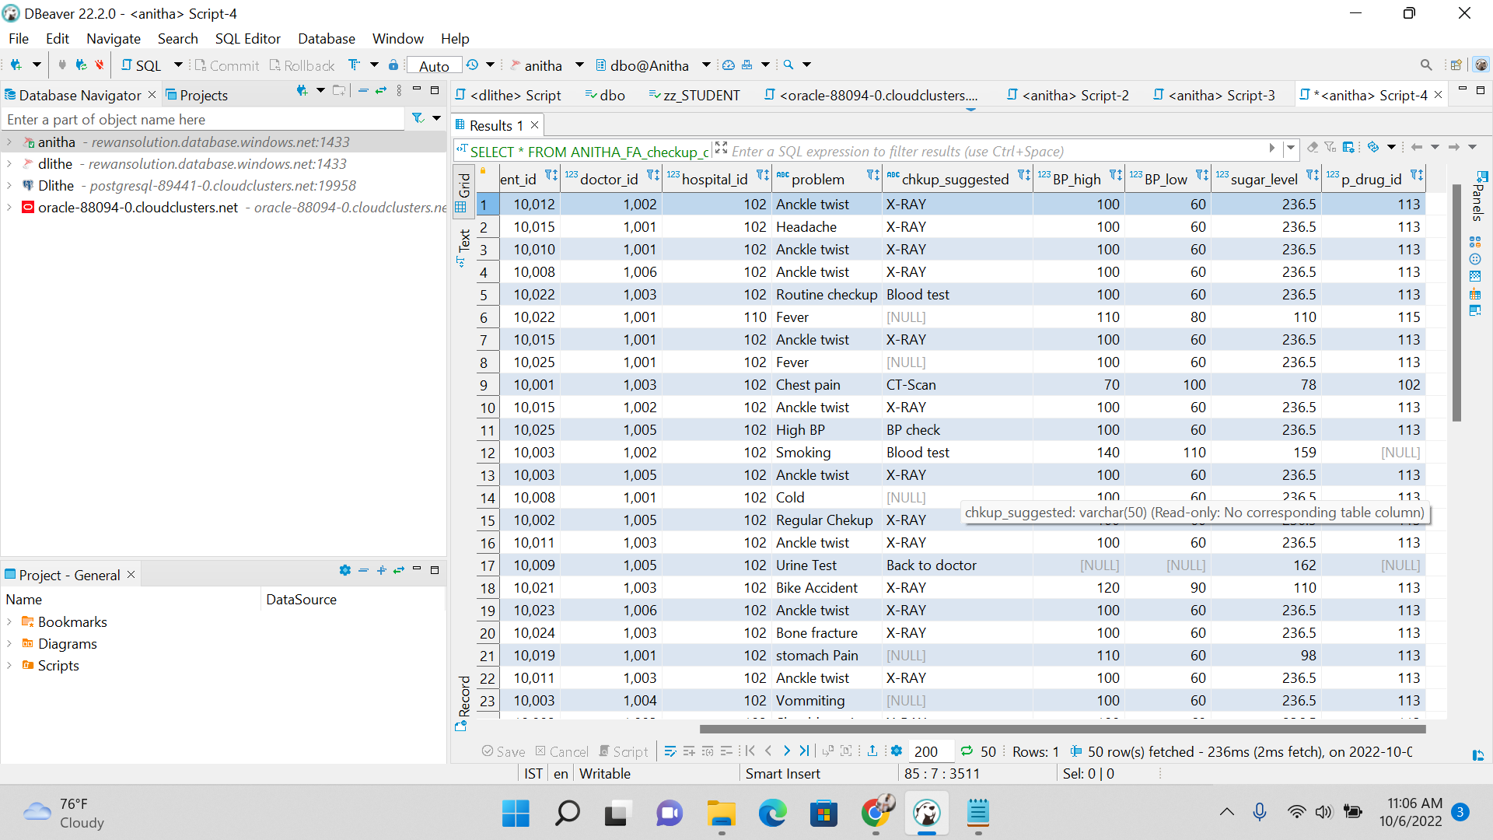

**2.ADDING THE CONSTRAINTS TO THE NORMALIZATION TABLES**

**alter** **table** ANITHA_FA_checkup_details **add** **constraint** FK_patient **foreign** **key**(patient_id) **references** ANITHA_FA_patient_records(p_id);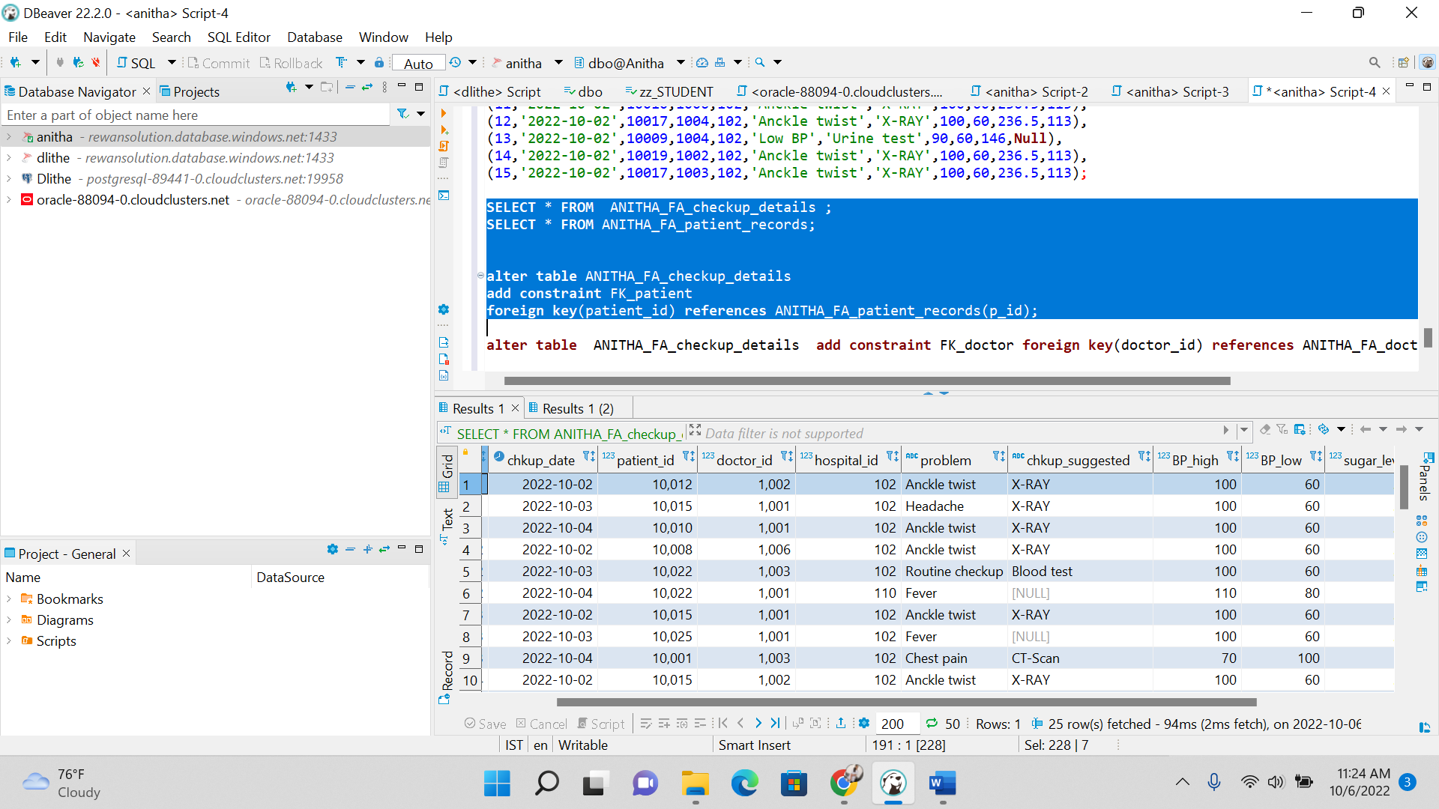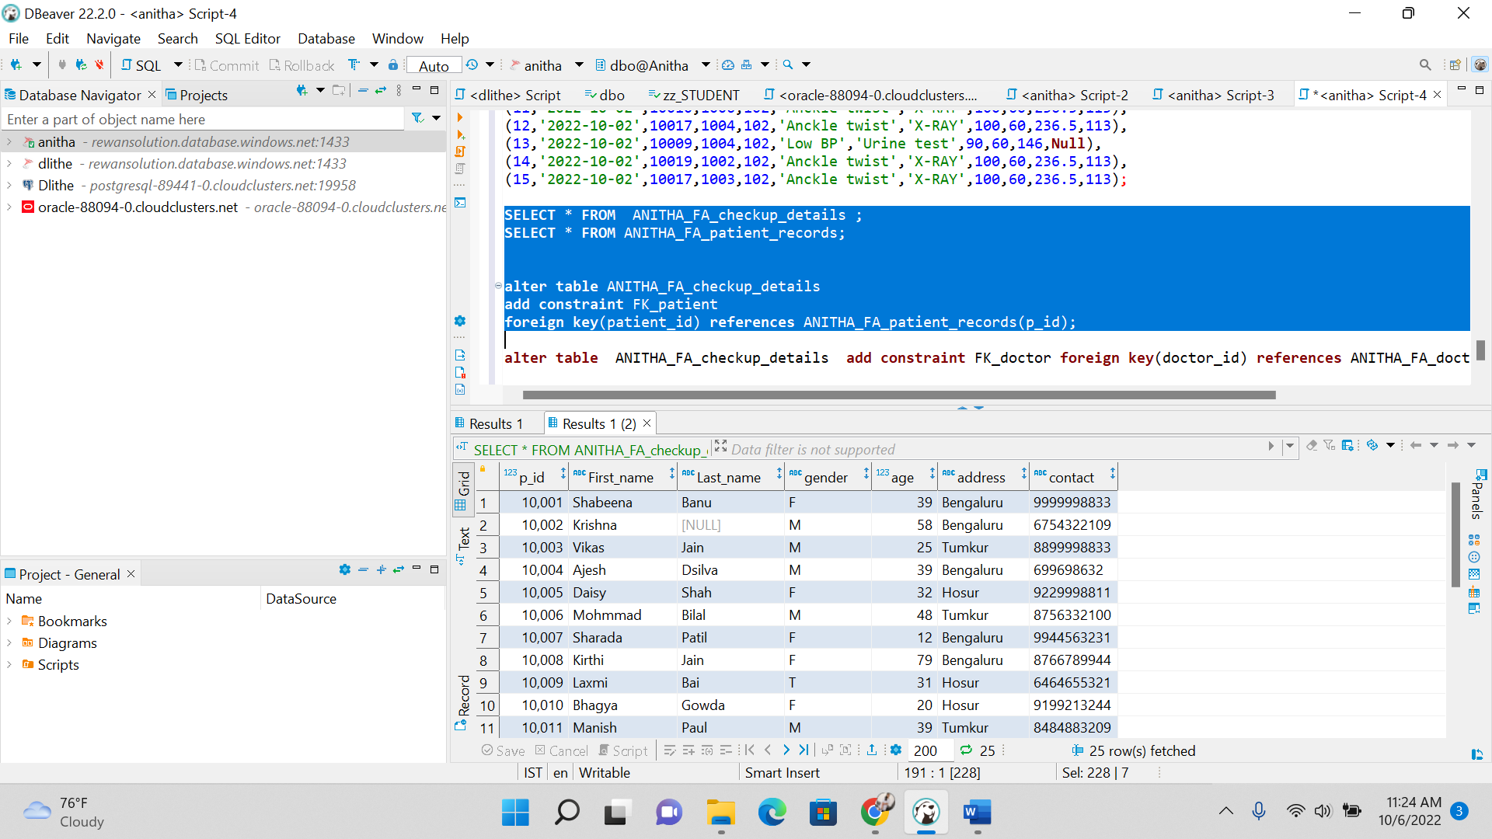

**alter** **table** ANITHA_FA_checkup_details **add** **constraint** FK_doctor **foreign** **key**(doctor_id) **references** ANITHA_FA_doctors(doctor_id);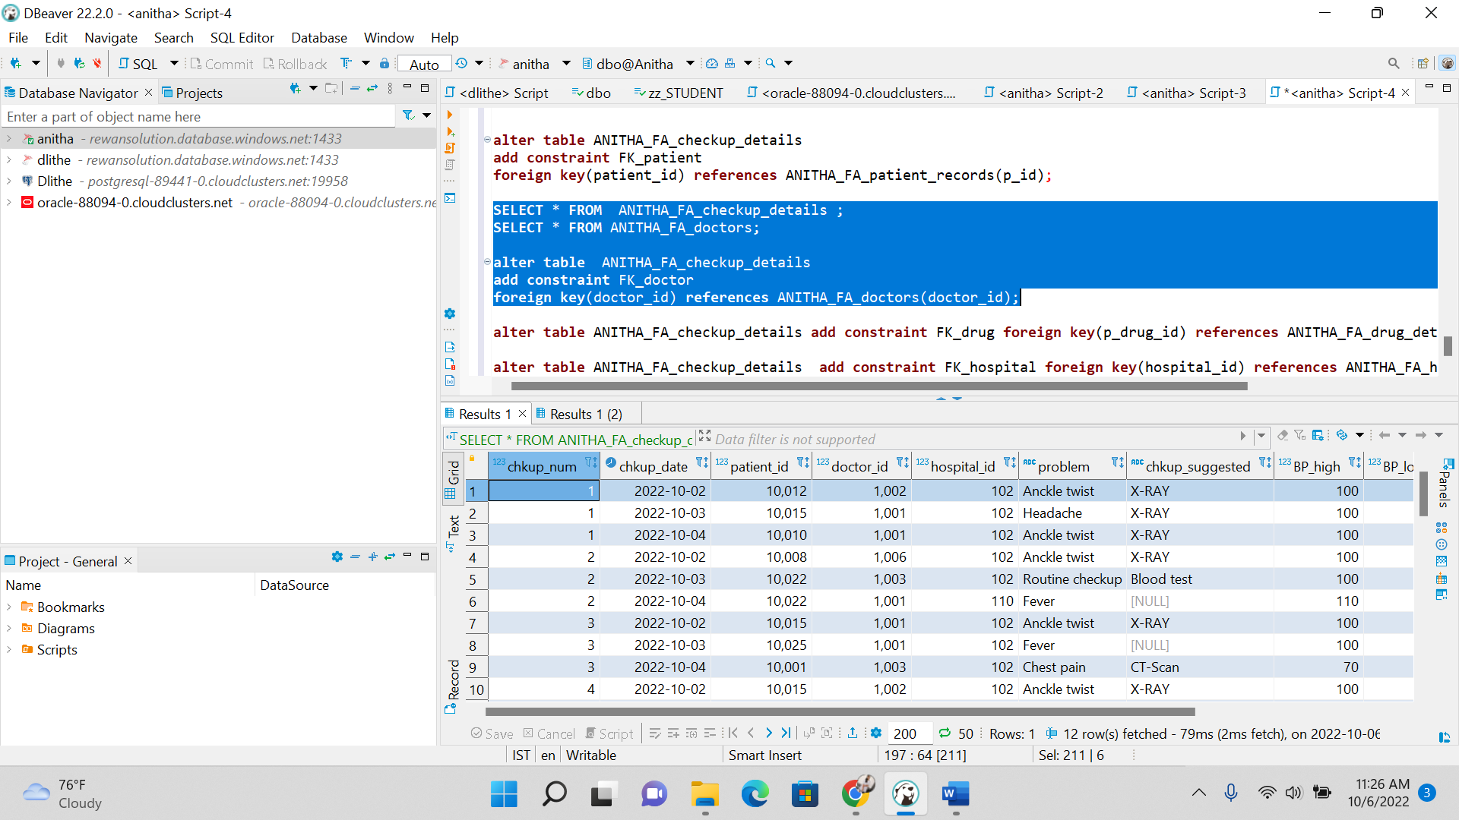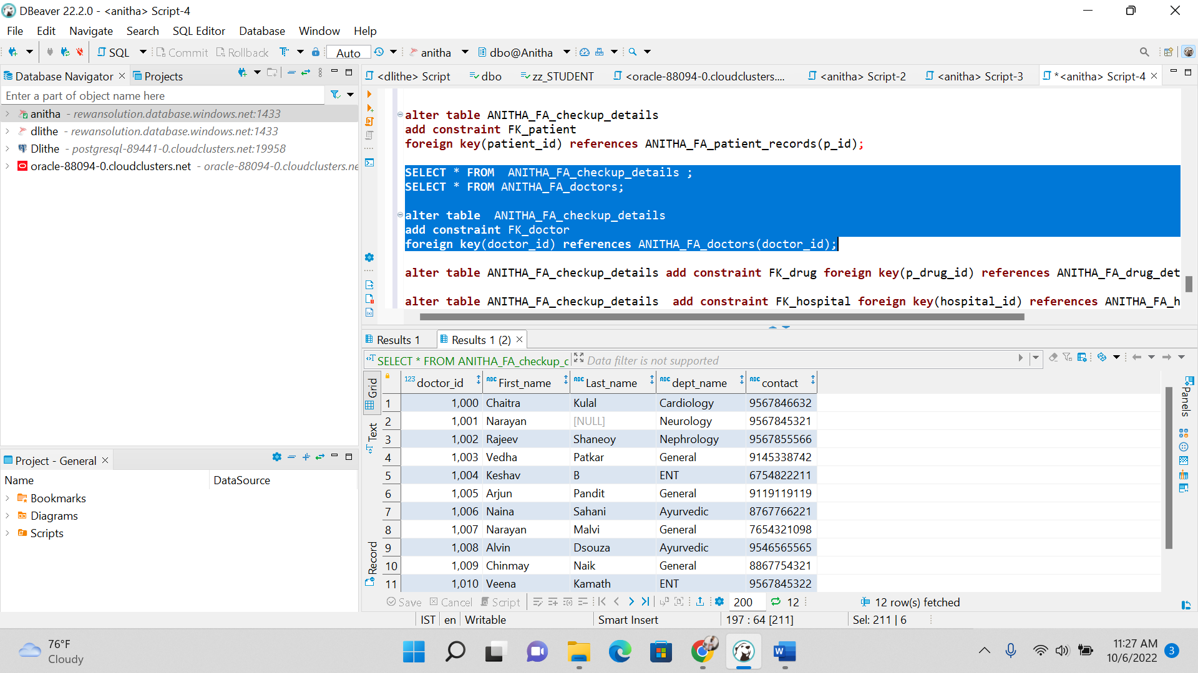

**alter** **table** ANITHA_FA_checkup_details **add** **constraint** FK_drug **foreign** **key**(p_drug_id) **references** ANITHA_FA_drug_details(drug_id);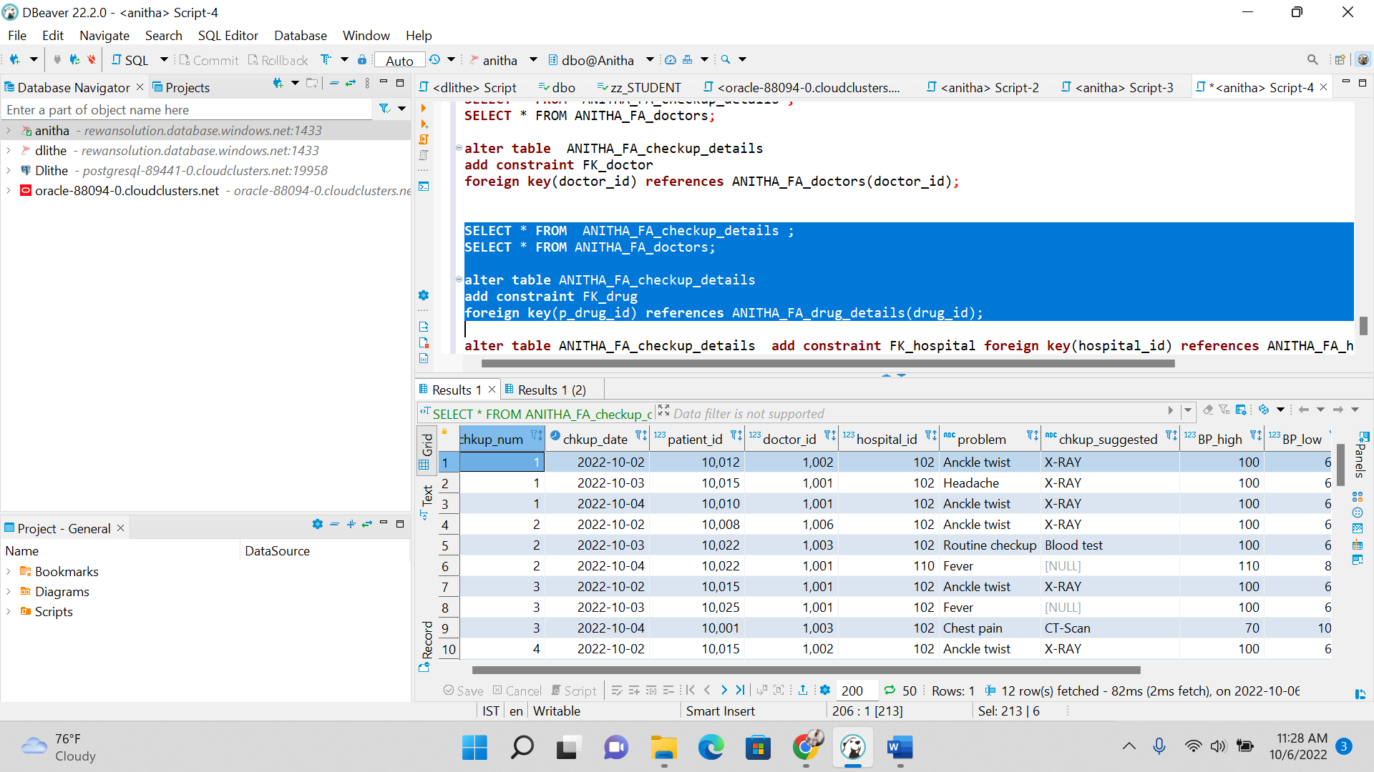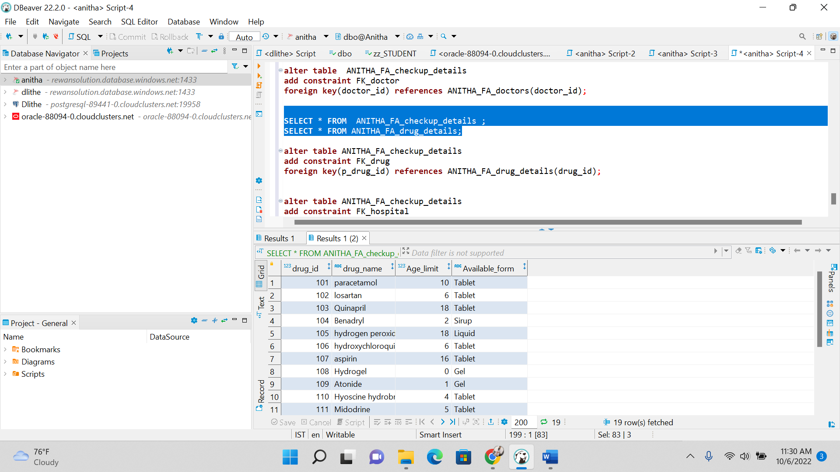

**alter** **table** ANITHA_FA_checkup_details **add** **constraint** FK_hospital **foreign** **key**(hospital_id) **references** ANITHA_FA_hospital_list(hospital_id);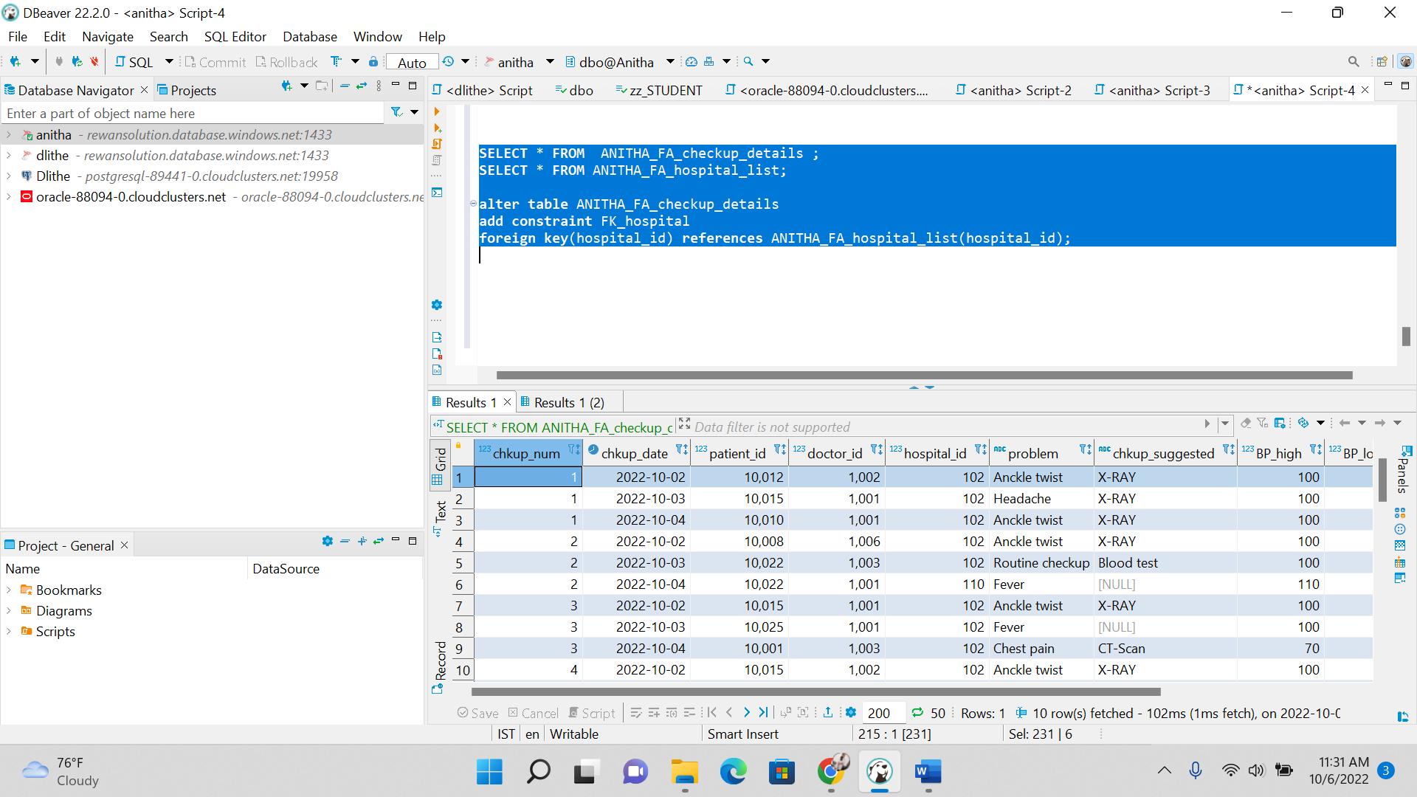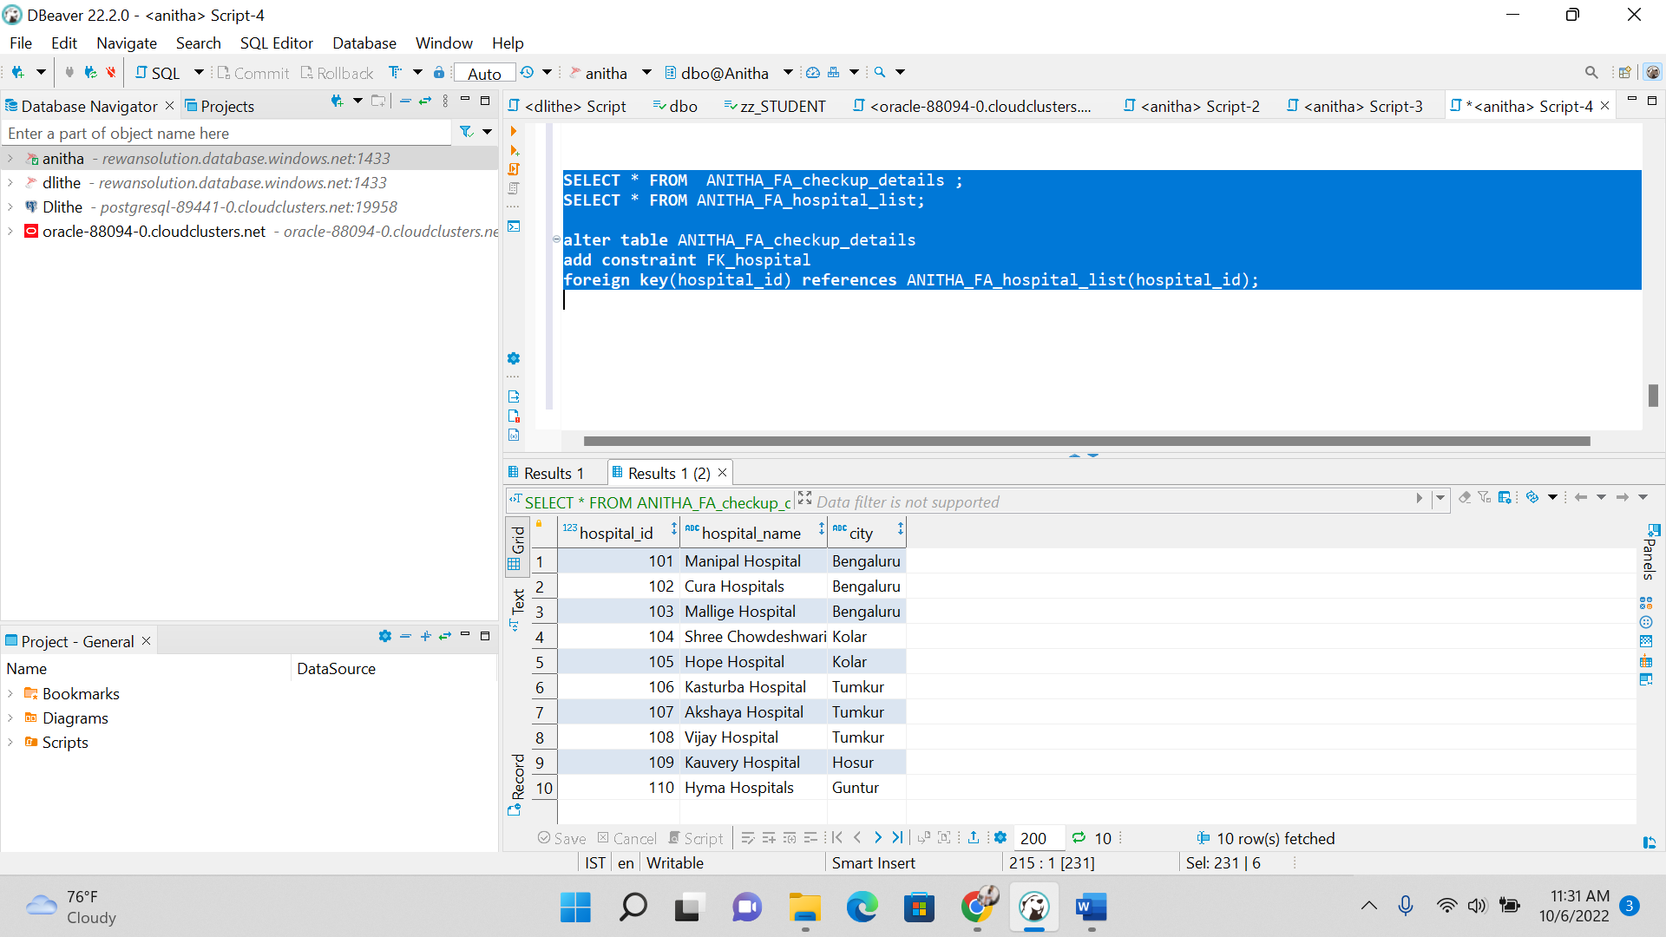

**3.CREATING VIEWS**

--------------------------------------VIEWS----------------------------------------

-----------1.CREATED A VIEW FOR CHECKUP DETAILS TABLE---------------------

**CREATE** **VIEW** ANITHA_FA_HEALTHCARE_VIEW

**AS**

**SELECT** * **FROM** ANITHA_FA_checkup_details;

**SELECT** **FROM** ANITHA_FA_HEALTHCARE_VIEW;

------------2. CREATED A VIEW FOR DRUG DETAILS TABLE----------------------

**CREATE** **VIEW** ANITHA_FA_HEALTHCARE_DET_VIEW

**AS**

**SELECT** * **FROM** ANITHA_FA_drug_details;

**SELECT** **FROM** ANITHA_FA_HEALTHCARE_DET_VIEW;

**4. CREATING THE JOINS INSIDE THE VIEWS**

**4.1. INNER JOIN**

----------------------------INNER JOIN------------------------------------

**CREATE** **VIEW** ANITHA_FA_HEALTHCARE_DET_VIEW

**AS**

**SELECT** C.chkup_num,C.chkup_date,C.problem,C.P_drug_id,D.drug_id,D.drug_name

**from** ANITHA_FA_checkup_details **as** C

**inner** **join** ANITHA_FA_drug_details **as** D

**on** C.P_drug_id = D.drug_id;

**SELECT** * **FROM** ANITHA_FA_HEALTHCARE_DET_VIEW;

**drop** **view** ANITHA_FA_HEALTHCARE_DET_VIEW;

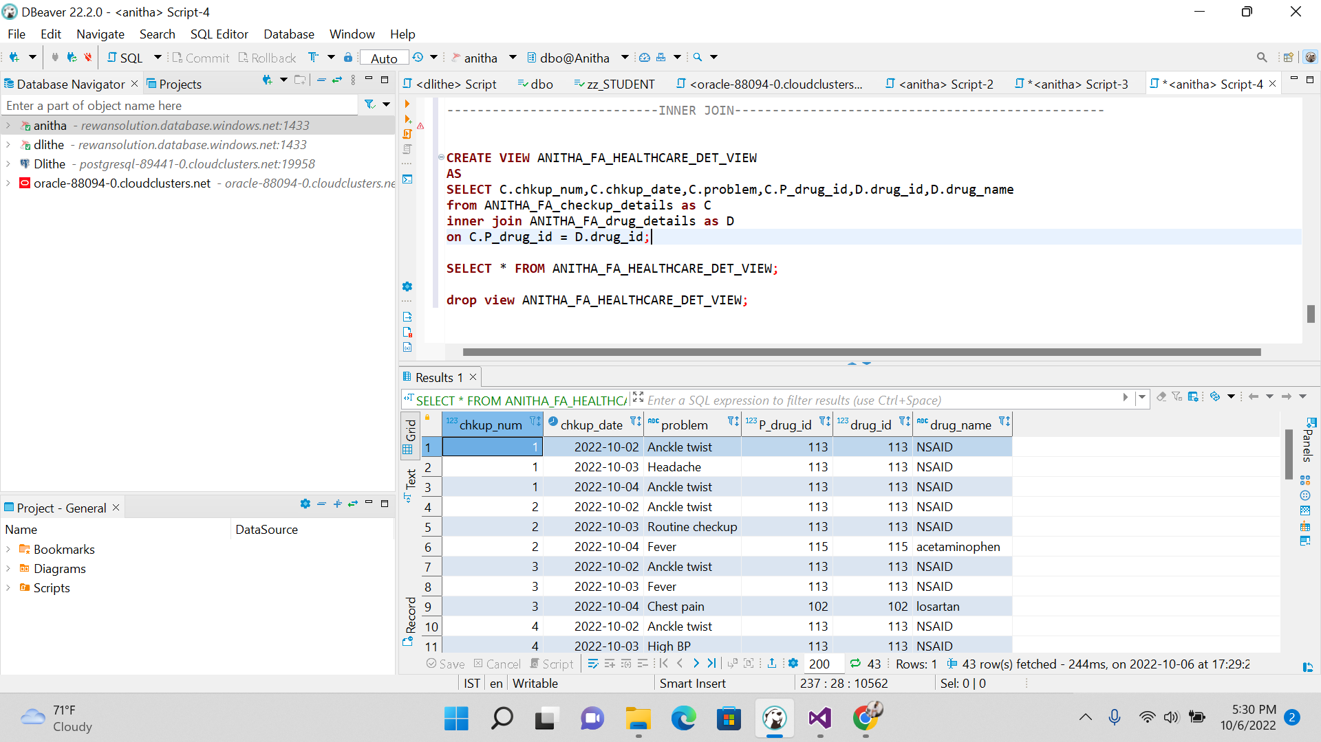

**4.2. LEFT JOIN**

-------------------------------------LEFT JOIN-------------------------------------

**CREATE** **VIEW** ANITHA_FA_HEALTHCARE_DET1_VIEW

**AS**

**SELECT** C.chkup_num,C.chkup_date,C.problem,C.P_drug_id,D.drug_id,D.drug_name

**from** ANITHA_FA_checkup_details **as** C

**LEFT** **join** ANITHA_FA_drug_details **as** D

**on** C.P_drug_id = D.drug_id;

**SELECT** * **FROM** ANITHA_FA_HEALTHCARE_DET1_VIEW;

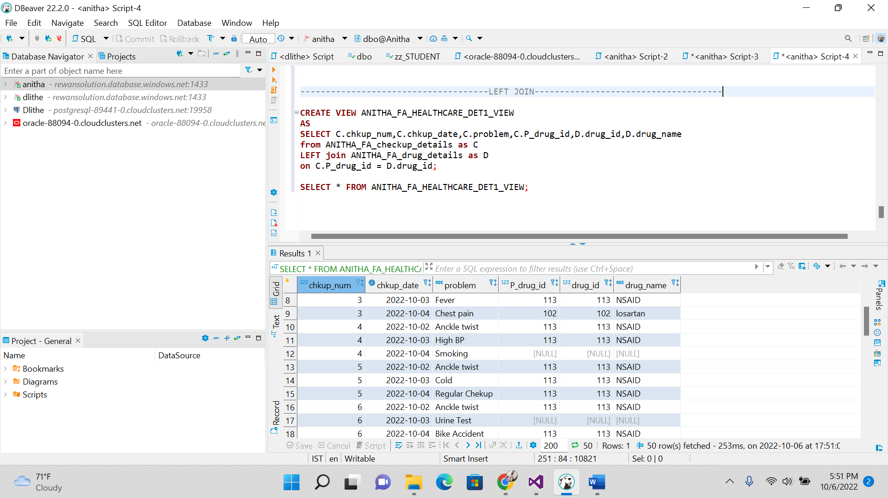

**4.3. RIGHT JOIN**

------------------------------------RIGHT JOIN------------------------------

**CREATE** **VIEW** ANITHA_FA_HEALTHCARE_DET2_VIEW

**AS**

**SELECT** C.chkup_num,C.chkup_date,C.problem,C.P_drug_id,D.drug_id,D.drug_name

**from** ANITHA_FA_checkup_details **as** C

**RIGHT** **join** ANITHA_FA_drug_details **as** D

**on** C.P_drug_id = D.drug_id;

**SELECT** * **FROM** ANITHA_FA_HEALTHCARE_DET2_VIEW;

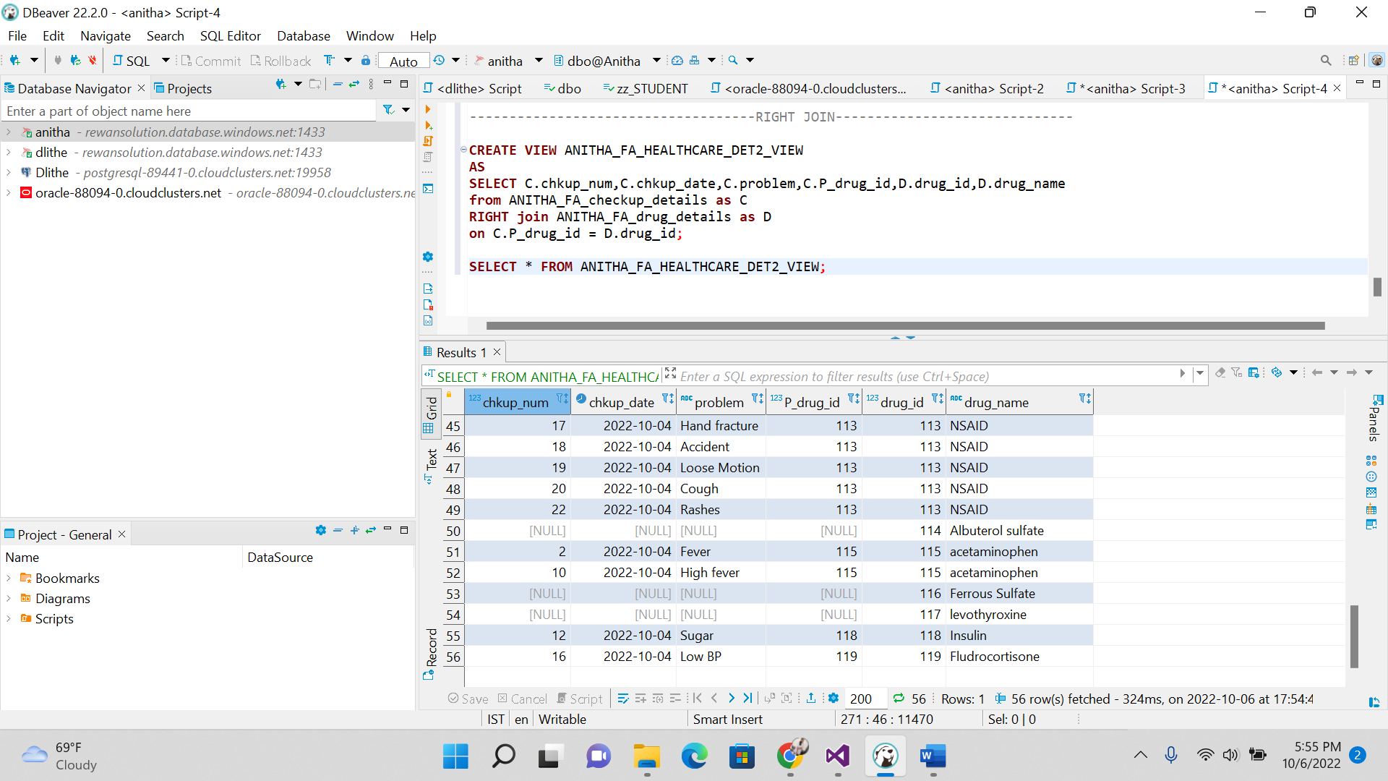

**4.4 FULL JOIN**

-----------------------------------FULL JOIN-------------------------------------

**CREATE** **VIEW** ANITHA_FA_HEALTHCARE_DET3_VIEW

**AS**

**SELECT** C.chkup_num,C.chkup_date,C.problem,C.P_drug_id,D.drug_id,D.drug_name

**from** ANITHA_FA_checkup_details **as** C

**FULL** **join** ANITHA_FA_drug_details **as** D

**on** C.P_drug_id = D.drug_id;

**SELECT** * **FROM** ANITHA_FA_HEALTHCARE_DET3_VIEW;

